Mathematics Component of NJGPA

Practice Test Answer and Alignment Document
Online

The following pages include the answer key for all machine-scored items, followed by the rubrics for the hand-scored items.
− The rubrics show sample student responses. Other valid methods for solving the problem can earn full credit unless a specific method is required by the item.
− In items where the scores are awarded for full and partial credit, the definition of partial credit will be confirmed during range-finding (reviewing sets of real student work).
− If students make a computation error, they can still earn points for reasoning or modeling.

Unit 1

Item Number | Answer Key | Evidence Statement | Course Alignment
Unit 1, Section 1
1. | in any order. | A-APR.3- 1 | Algebra 1
2. | Part A:  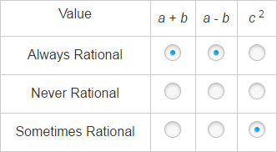 | N-RN.B-1 | Algebra 1

 | Part B: B
3. | B | A-SSE.3a | Algebra 1
4. | C | A-APR.1-  1 | Algebra 1
5. | A | G-SRT.6 | Geometry
6. | Part A: x + y = 16  2x + 3y = 39  Part B: 7 | F-IF.2 | Algebra 1
7. | 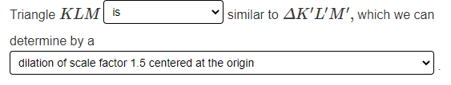 | G-SRT.2 | Geometry
8. | 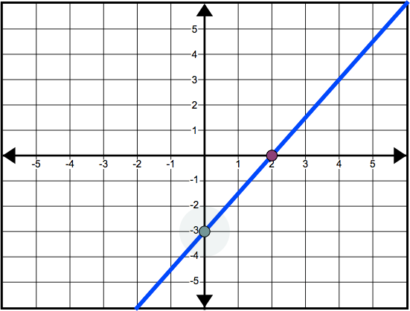 | F-IF.7a-1 | Algebra 1
Unit 1, Section 2
1. | Part A: B  Part B: A | G-CO.D | Geometry
2. | B | G-CO.3 | Geometry
3. | See rubric | HS-D.1-2 | Geometry
4. | Part A: 36  Part B: 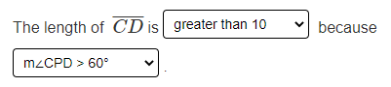 | G-C.2 | Geometry
5. | See rubric | HS-C.6.1 | Algebra 1
6. | Part A: 3.4  Part B: C | G-SRT.8 | Geometry
7. | B | F-IF.4-1 | Algebra 1
8. |  | A-REI.4b-1 | Algebra 1

Unit 2

Item Number | Answer Key | Evidence Statement | Course Alignment
1. | See Rubric | HS-D.2-2 | Geometry
2. | Part A:  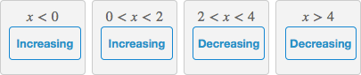  Part B:  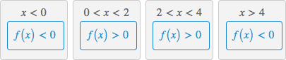 | F-IF.4-1 | Algebra 1
3. | C, E | A-REI.3 | Algebra 1
4. | 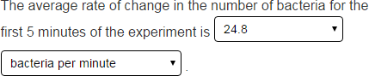 | F-IF.6-1a | Algebra 1
5. | 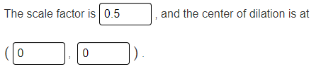 | G-SRT.1b | Geometry

6. | Part A: 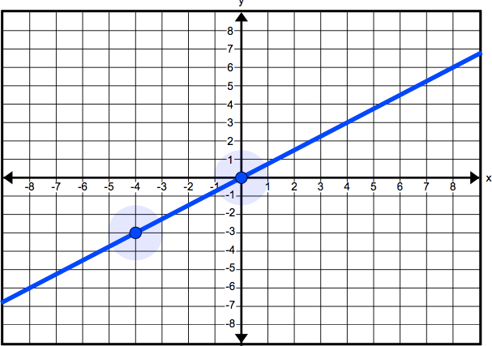  Part B: See Rubric  Part C: See Rubric | HS-C.18.1 | Algebra 1
7. | B | A-CED.4-2 | Algebra 1
8. | B, F | G-CO.1 | Geometry
9. | N (t) = 150(3)^{t} | F-LE.2-1 | Algebra 1
10. | B | G-GMD.3 | Geometry
11. | See rubric | HS-C.14.5 | Geometry
12. | Part A: See rubric  Part B: See rubric | HS-D.2-9 | Algebra 1
13. | B, F | G-GMD.1 | Geometry
Rubrics start on the next page.

Unit 1 #3 Part A
Score | Description
3 | Student response includes each of the following 3 elements:  - Correct identification of the shape of the exposed surface as a rectangle  - Correct area of the rectangle  - Valid work shown Sample Student Response:  The shape of the exposed surface is a rectangle.  The width of this rectangle is the length of one edge of the cube, which is 10 inches. The length of the rectangle, d, is the length of the diagonal of a square face of the cube. To find this length, apply the Pythagorean Theorem.  c ² = a ² + b ²  d ² = 10 ² + 10 ²  d ² = 200  d = 200 ≈ 14.1 (inches)  The length of the diagonal of a face of the cube is approximately 14.1 inches. The area of the rectangle (exposed surface) is 10 √200 ≈ 141 square inches.
2 | Student response includes 2 of the 3 elements.
1 | Student response includes 1 of the 3 elements.
0 | Student response is incorrect or irrelevant.

Unit 1 #3 Part B
3 | Student response includes each of the following 3 elements:  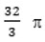  - Correct conclusion that the volume of clay in the chunk is 500 cubic inches  - Correct conclusion that the volume of each clay sphere is cubic inches, or approximately 33.5 cubic inches  - Correct conclusion that Daniel can make 14 clay spheres, with calculations to support that conclusion  Sample Student Response:  The volume of each congruent chunk is half the volume of the entire block. The volume of the cube is (10 inches)³, or 1,000 cubic inches. So the volume of each congruent chunk of clay is 500 cubic inches.  Each sphere will have a diameter of $\frac{4}{3}$ inches and a radius of 2 inches. The volume of each clay sphere will be $\frac{4}{3}$ π(2 inches)3, or $\frac{32}{3}$ π cubic inches. This is approximately 33.5 cubic inches.  To find the number of spheres that Daniel can make from the chunk of clay, divide the volume of the full chunk of clay, by the volume of one sphere:  500 ÷ 33.5 ≈ 14.9.  The result of 14.9 means that there is enough clay in the chunk to make 14 clay spheres because there is not enough clay to make 15 complete spheres.
2 | Student response includes 2 of the above elements.
1 | Student response includes 1 of the above elements.
0 | Student response is incorrect or irrelevant.

Unit 1 #5
Score | Description
3 | Student response includes each of the following 3 elements:  - Correct justification of the number of points on the graph for  c < 0  - Correct justification of the number of points on the graph for  c = 0  - Correct justification of the number of points on the graph for  c > 0  Sample Student Response:  - |x| and |y| are each nonnegative for all real numbers x and y. So, the sum must be nonnegative for all real numbers. Therefore, the sum cannot equal a negative number. There are no  solutions and no points on the graph c > 0  - If c = 0, there is only one solution, (0, 0). The graph consists of only one point.  - If c > 0, there are infinitely many solutions, which means that  there are infinitely many points on the graph.
2 | Student response includes 2 of the 3 elements.
1 | Student response includes 1 of the 3 elements.
0 | Student response is incorrect or irrelevant.

Unit 2 #1
Score | Description
3 | Student response includes each of the following 3 elements:  - Valid values for h1 and h2  - Valid approach for determining h1 and h2  - Verification that the design will store at least 2 dump-truck loads of fertilizer Sample Student Response:  Assuming the dump trucks are rectangular prisms, each dump truck stores 288 cubic  feet of fertilizer (4 × 6 × 12 = 288). Two dump trucks will store 576 cubic feet of fertilizer. The volume of the storage building needs to be at least 576 cubic feet. The volume of the storage building equals the volume of the cylinder plus the volume of the cone. I used the maximum diameter of 8 feet.  πr ²h1 + 1 πr ²h2  3  4²πh1 + 1 π4²h2  3  I used the maximum total height of 14 feet. Since the volume of a cone involves dividing by 3, I made the height of the cone much smaller than the height of the cylinder.  π4²h1 + 1 π4²h2  3  π4²11 + 1 π4²3 ≈ 603.16  3  Using h₁ = 11 feet and h₂ = 3 feet, the storage building will have a volume greater than 576 cubic feet.  Note: Any two heights that create a volume greater than 576 are acceptable.
2 | Student response includes 2 of the above elements.
1 | Student response includes 1 of the above elements.
0 | Student response is incorrect or irrelevant.

Unit 2 #6
Part B
2 | Student response includes each of the following 2 elements:  - Explanation of why the coordinate values have the same ratio  - Explanation of the exception regarding the y-intercept  Sample Student Response:  The graph passes through the origin, so if (x, y) is a point on  the line, then the slope can be represented by y − 0 which is  x − 0  the same as the ratio of the coordinate values. Because the slope is constant, the ratio is the same for all points on the line, with the exception of the y-intercept which is (0, 0). The y-intercept (the origin) does not work because 0 divided by 0 is undefined.
1 | Student response includes 1 of the 2 elements.
0 | Student response is incorrect or irrelevant.

Unit 2 #6
Part C
1 | Student response includes the following element:  - Explanation why the line does not have the same property as in Part B  Sample Student Response:  The equation y = 3x − 2 has a y-intercept of −2, so the line  will not pass through the origin. As a result, the line will not have the same property as in Part B.
0 | Student response is incorrect or irrelevant.

Unit 2 #11
Score | Description
3 | Student has complete valid proof with valid chains of reasoning.  Student Sample Response:  Given: A′B′ is the image of AB after a dilation centered at point C and with scale factor k, k > 0.  Prove: A’B’ = k ·AB.  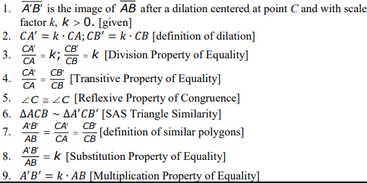  Note: Other forms of proof will be accepted.
2 | Student response contains a valid chain of reasoning but may omit some information. The student must include the SAS Triangle Similarity property correctly.
1 | Student response includes valid justified steps, but is an incomplete proof.
0 | Student response is incorrect or irrelevant.

Unit 2 #12 Part A
Score | Description
3 | Student response includes each of the following 3 elements:  - Correct model  - Valid work shown  - Valid explanation of d with relation to 450.  Sample Student Response:  For 20 minutes of shower time, the family can save (5 − 2)(20) = 60 gallons each day. At $0.002 per gallon, this is a savings of $0.12 per day.  Let S represent the cost savings, in dollars, and let d represent the time in days:  S = –54 + 0.12d.  The number of days at which the savings become zero can be found by solving this equation:  –54 + 0.12d = 0  0.12d = 54  d = 450  For values of d less than 450, the savings due to reduced water consumption have not yet exceeded the cost of the low-flow showerhead. For values of d greater than 450, the savings due to reduced water consumption have exceeded the cost of the low-flow showerhead. Therefore, the cost savings will be greater than zero after 450 days.
2 | Student response includes 2 of the 3 elements.
1 | Student response includes 1 of the 3 elements.
0 | Student response is incorrect or irrelevant.

Unit 2 #12 Part B
3 | Student response includes each of the following 3 elements:  - Correct model  - Valid work shown  - Correct computation and interpretation of 81  Sample Student Response:  In the first year, the savings in water costs are (365)($0.12) = $43.80. The low-  flow showerhead costs $54, and so there is still $54 − $43.80 = $10.20 to recover. After the first year, the cost savings will be (12)(1.05) = 12.6 cents, or  $0.126 per day. So if S represents the savings and d2 represents the number of days in the second year, then the new model is:  S = −10.2 + 0.126d₂  The number of days at which the savings become zero can be found by solving this equation:  −10.2 + 0.126d₂ = 0  0.126d₂ = 10.2  d2 ≈ 81  The family will start saving money 81 days into the second year.  Note: The student will earn the point if he or she correctly interprets his or her reasonable incorrect model.
2 | Student response includes 2 of the 3 elements.
1 | Student response includes 1 of the 3 elements.
0 | Student response is incorrect or irrelevant.

